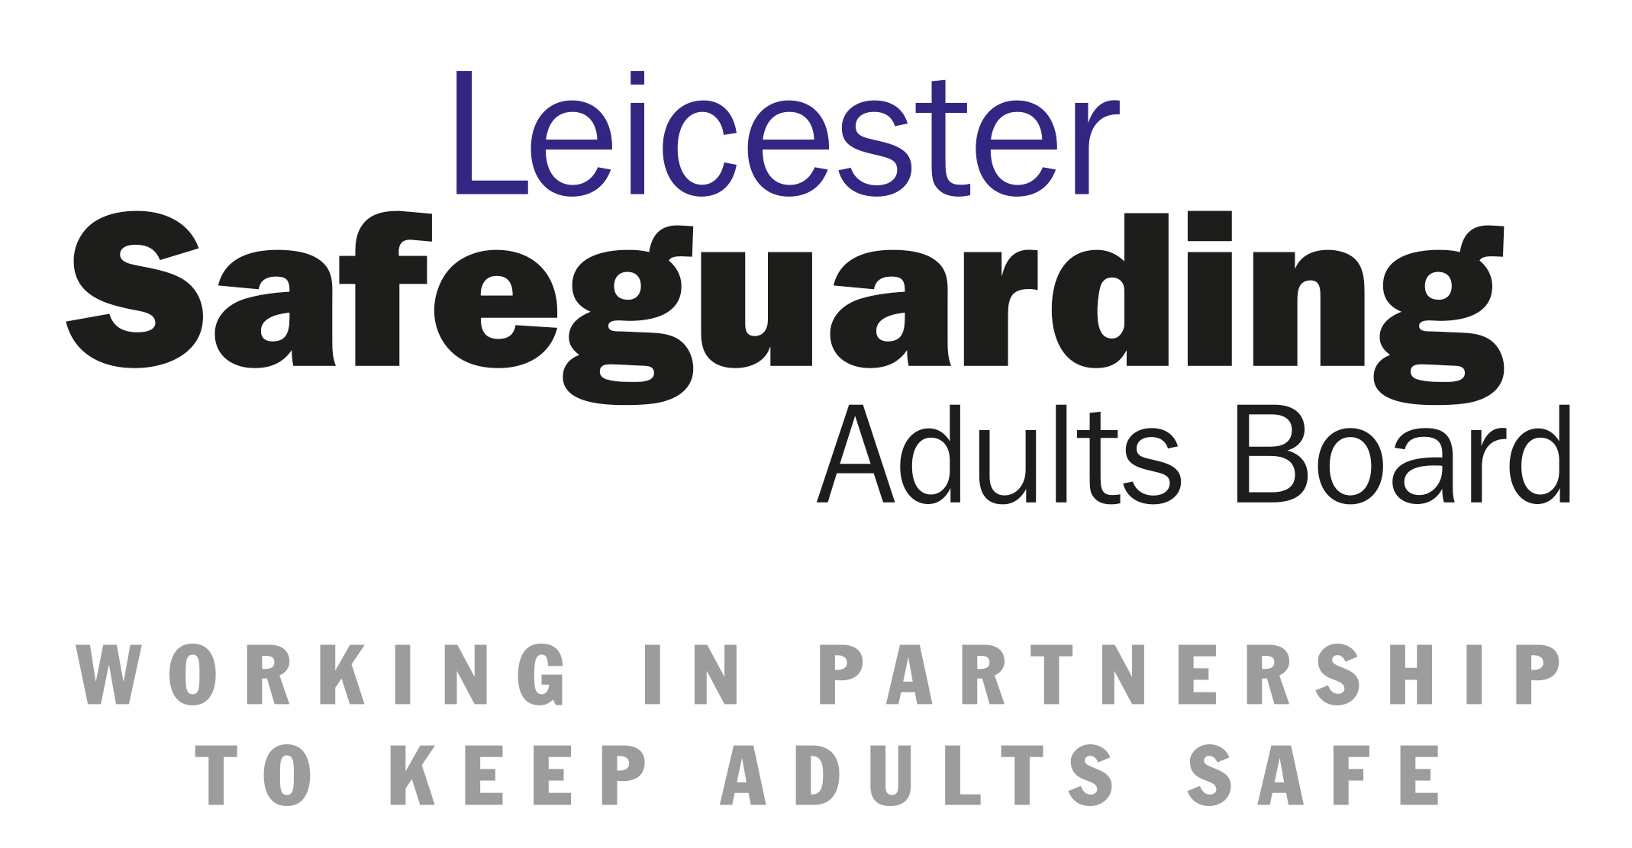 

**Appendix A - Safeguarding Adults Competency Framework Log**

Please remember that the evidence to meet the competency should be **proportionate** to the individual’s roles and responsibilities, in order that it is relevant, meaningful and appropriate.

The competencies are set out below in suggested groupings. All staff must complete competencies 1 – 3 which are the Core Competencies. Some staff must then complete additional competencies to reflect their role and responsibilities.

Managers and staff/volunteers are able to add to their competencies from other groups if they believe this to be relevant. There are also spaces on the suggested template to add additional competencies should this be relevant.

**A complete list of the competencies is available at Appendix B**.

|  |  |  |  |
| --- | --- | --- | --- |
| **Competencies 1 – 3** | **Description**  *For all staff.* | **Evidence or Demonstration of Competence and Dates Taken Place Within the Previous Six Months** | **Review Date (minimum requirement 12 monthly)** |
|  | Understand what the term ‘Safeguarding Adults’ means.   * 1. *The definition of an adult who may be ‘at risk’, is defined in the LLR Multi-Agency Policy and Procedures 2018, Care Act 2014.* |  |  |
|  | Understand your role as defined within the multi-agency and internal policy and procedure, including how to report concerns of abuse of either adults or children, including historical abuse, using appropriate systems. This includes how to report concerns in a variety of settings, including prisons. |  |  |
|  | Know and explain what to do if abuse of an adult is suspected; including how to raise concerns within local whistle blowing policy procedures. |  |  |
| **Competencies 4 – 10** | **Description**  *For staff with staff with responsibility for providing direct care and/or with professional and organisational responsibility for safeguarding adults, able to act on concerns and to work within an inter- or multi-agency context, i.e. non-qualified social care staff, care management officers, referral-takers, seniors within provider settings etc.* | **Evidence or Demonstration of Competence and Dates Taken Place Within the Previous Six Months** | **Review Date (minimum requirement 12 monthly)** |
| **4.** | Understand your role in responding appropriately to safeguarding alerts and referrals. |  |  |
| **5.** | Understand the types and signs of abuse, as defined by LLR Multi-Agency Policy and Procedures 2018, The Care Act 2014.  *Please note: this is not a list to be completed; it is about demonstrating understanding in this area of what constitutes abuse.* |  |  |
| **6.** | Be aware of relevant legislation, local and national policies and procedures which relate to safeguarding adults.  *I.e. VARM, PiPoT, MCA and DoLS.* |  |  |
| **7.** | Know how to apply the basic principles of helping people to keep themselves safe. |  |  |
| **8.** | Know how to support people to think about risk when exercising choice and control. |  |  |
| **9.** | Know how to offer appropriate support, advice and/or signposting where Safeguarding Adults criteria are not met. |  |  |
| **10.** | Know the local arrangements for the implementation of multi-agency Safeguarding Adults policies and procedures, including Thresholds. |  |  |
| **Competencies 11 – 20** | **Description**  *For staff with responsibility under Section 42 of the Care Act, which places a duty on local authorities to make enquiries, or to ask others to make enquiries, where they reasonably suspect that an adult in its area is at risk of neglect or abuse, including financial abuse. The purpose of the enquiry is to establish with the individual and/or their representatives, what, if any, action is required in relation to the situation; and to establish who should take such action.*  *This could include social workers, care home managers and seniors.* | **Evidence or Demonstration of Competence and Dates Taken Place Within the Previous Six Months** | **Review Date (minimum requirement 12 monthly)** |
| **11.** | Understand the thresholds guidance in response to a safeguarding referral. |  |  |
| **12.** | Understand how to apply relevant legislation, local and national policies and procedures in relation to safeguarding adult enquiries. |  |  |
| **13.** | Be able to support adults at risk, advocates and informal carers to understand safeguarding issues to maximise their decision making in line with Making Safeguarding Personal. |  |  |
| **14.** | Understand your role in contributing to strategy meetings/discussions and conferences. |  |  |
| **15.** | Be able to identify and reduce potential and actual risk and understand how to support people to keep safe, including dealing with immediate risk. |  |  |
| **16.** | Be able to develop, and contribute to, protective strategies or protection plans, including for those that decline services. |  |  |
| **17.** | Understand when to refer to the Police, where there may be a criminal aspect, to safeguard adults.  *Local agreements apply.* |  |  |
| **18.** | Understand the roles and responsibilities of the different agencies involved in making enquiries into allegations of abuse or neglect.  *I.e. Delegated tasks* |  |  |
| **19.** | Understand the importance of sharing information with the relevant agencies. |  |  |
| **20.** | Understand how to support people within local whistle blowing policy procedures. |  |  |
| **Competencies 21 – 27** | **Description**  *For staff with management and supervisory responsibilities for safeguarding enquiries.* | **Evidence or Demonstration of Competence and Dates Taken Place Within the Previous Six Months** | **Review Date (minimum requirement 12 monthly)** |
| **21.** | Understand your role as a manager with the potential for delegated responsibilities within the enquiry process. |  |  |
| **22.** | Make sound and consistent decisions as part of  implementing the local policy and procedure. |  |  |
| **23.** | Carry out robust, effective and timely supervision with staff, ensuring that the staff you manage are competent to undertake their duties (as per the Competency Framework) and engaged, as appropriate, in safeguarding adults enquiries |  |  |
|  | **Please note: Competencies 24 – 27 are for the Lead Agency (Local Authority Adult Social Care) Only** |  |  |
| **24.** | Provide support, guidance and oversight to those with delegated responsibilities within the enquiry process. |  |  |
| **25.** | Be able to convene and chair Safeguarding Adults Conferences, strategy meetings or VARM. |  |  |
| **26.** | Ensure that adults at risk, advocates and carers are supported and involved in the conference process, as appropriate, as per the principles of Making Safeguarding Personal. |  |  |
| **27.** | Understand the roles and responsibilities of operational managers within the multi-agency Safeguarding Adults process. |  |  |
| **Competencies 28 – 34** | **Description**  *For leads with responsibility for the development of effective Safeguarding practice within their service area i.e. Principal Social Workers and Lead Practitioners* | **Evidence or Demonstration of Competence and Dates Taken Place Within the Previous Six Months** | **Review Date (minimum requirement 12 monthly)** |
| **28.** | Lead the development of effective policy and procedures for safeguarding adults in your organisation. |  |  |
| **29.** | Ensure practitioners across your service are supported in their safeguarding practice via the promotion of Continuous Professional Development including promoting learning from research, case law and national updates. |  |  |
| **30.** | Undertake an advisory role to the director of adult social services (DASS) and/or wider council in complex or controversial cases. |  |  |
| **31.** | Promote awareness of Safeguarding Adults within your organisation and outside your organisation. |  |  |
| **32.** | Develop and maintain systems to ensure the involvement of those who use your services in the evaluation and development of your Safeguarding Adults services. |  |  |
| **33.** | Lead on the development of learning from Safeguarding Adults Reviews, Domestic Homicide Reviews and Appreciative Enquiries, Learning Disability Mortality Reviews and ensure that lessons learned are embedded within practice. |  |  |
| **34.** | Understand your role and relationship with the work of the Safeguarding Adults Board (SAB) and identified priorities defined by the SAB. |  |  |
| **Competencies 35 – 36** | **Description**  *Additional levels for SAB Board Managers or Business Managers* | **Evidence or Demonstration of Competence and Dates Taken Place Within the Previous Six Months** | **Review Date (minimum requirement 12 monthly)** |
| **35.** | Contribute towards, and facilitate, the creation of:   * a Strategic Plan (Care Act 2014, Sch 2, para 3), and * an Annual Report (Care Act 2014, Sch 2, para 4)   for the Safeguarding Adults Board (SAB) to satisfy its statutory functions. |  |  |
| **36.** | Support the SAB to undertake Safeguarding Adults Reviews as set out in the Care Act 2014, s44. |  |  |
| **Competencies 37 – 40** | ***Description***  *Additional levels for SAB Board members, DASS and ADs* | **Evidence or Demonstration of Competence and Dates Taken Place Within the Previous Six Months** | **Review Date (minimum requirement 12 monthly)** |
| **37.** | Understand your role in promoting prevention, early intervention and partnership working in the development of effective safeguarding within your organisation. |  |  |
| **38.** | Lead on promoting a culture that is person-centred, supports choice and control and aims to tackle inequalities. |  |  |
| **39.** | Evidence an awareness of and ability to respond to national developments and ask searching questions within your own organisation to assure yourself that your systems and practices are effective in recognising and preventing abuse and neglect. |  |  |
| **40.** | Understand your role and relationship with the work of the Safeguarding Adults Board (SAB) and developing key priorities as part of the SAB. |  |  |